
SPECIFICATION
FOR APPROVAL
Part name：Din-Rail Terminal Block(RTB)H
Part No.：RTB450-00-01-9
Cust. P/N：
Date：2006-9-09

Seller Confirmation Customer Confirmation
Written by | Maker Liu |  | Project Audit
Checked by | Mac. He |  | Structure Audit
Approved by | Sun Li |  | Security Certification
 |  |  | Quality Approval

Supplier : Hangzhou antron electronics Co., Ltd.
Address : No.639 , Deng yun Road , Hangzhou China
Tel : 0571-89902210
Fax : 0571-89908128
Postcode: 310011
E-mail : anqiao@263.net

Customer: Customer P/N:
Seller: Hangzhou antron electronics Co., Ltd Part No: RTB450-00-01-9

Revision for RTB450-00-01-9
Item No | Edition | Part Revised | Date Revised
1 | A | put in file | 2006-9-09
2
3
4
5
6
7
8
9

1.TYPE：RTB450-00-01-9
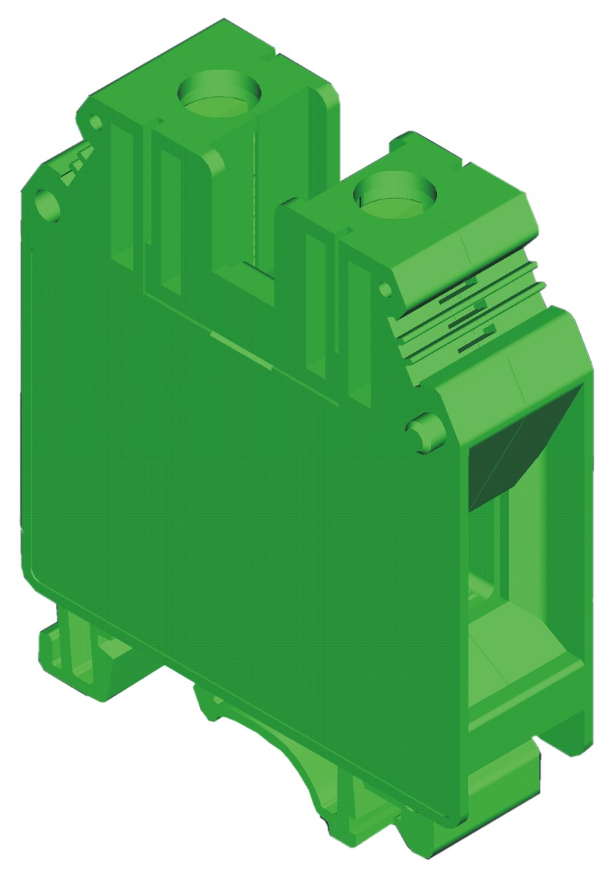

2.DRAWING&SIZES
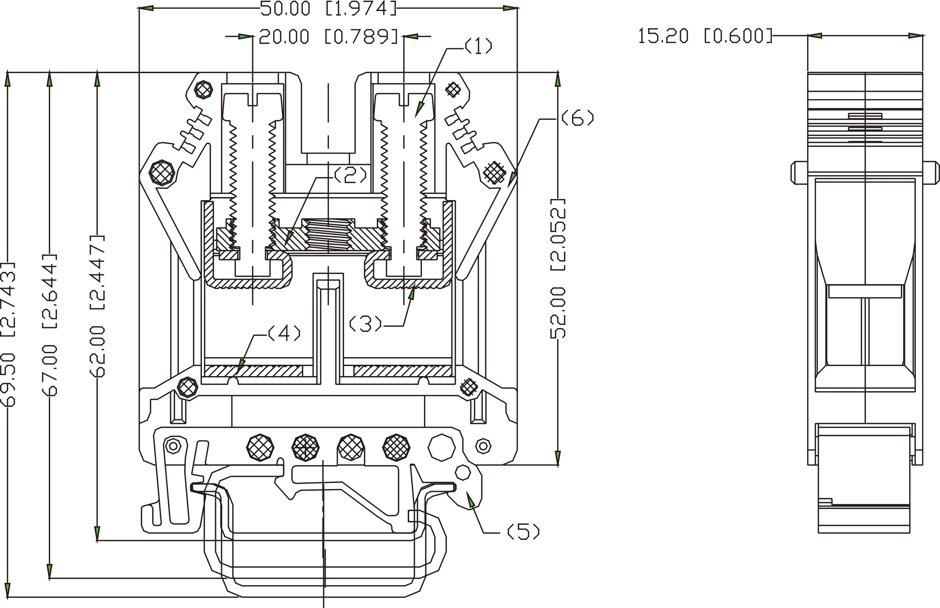
OVERALL SIZES
TOLERANCE：
＞120 | ±0.80
＞30～120 | ±0.50
＞6～30 | ±0.40
0～6 | ±0.25

3.BOM TABLE
ITEM. | PART NAME | MATERIAL | SURFACE OF CONTACT | QUANTITY(PCS)
(1) | Screw | Brass H59 | Zn Plated 5um | 2
(2) | Coupling | Brass H59 | Ni Plated 5um | 1
(3) | Contact | Brass H62 | Sn Plated 5um | 2
(4) | Block mount | Brass H59 | Ni Plated 5um | 1
(5) | Nip Rail | PA66(UL94 V-0) |  | 1
(6) | Housing | PA66(UL94 V-0) |  | 2

5.TECHNICAL DATA:
WIRE RANGE： 18～2AWG
MAX. TORQUE： 3.2 Nm～3.7 Nm
ELECTRICAL RATING： 800V, 125A.
DIELECTRIC WITHSTAND： AC3500V, 1 minute
BREAKDOWN VOLTAGE: 8000V (1.2/50μs),
CROSS SECTION： 35mm²
STRIPPING LENGTH： 16mm
6.WORKING CONDITION：
OPERATING TEMPERATURE：-40℃～+105℃
ALTITUDE： Less than 2000m 40Kpa～80KPa
RELATIVE HUMIDITY： 5%～95%
POLLUTION DEGREE： Ⅲ
7.APPLICABLE STANDARDS
IEC 60947-1:2001 IEC 60947-7-1:2002 UL 1059:2001
七.ACCESSORIES
MOUNTING RAIL: JNS35:7.5/JNS35:15/JNS32
FIXED BRIDGE: A042-02-22/ A042-03-22
SEPARATING PLATE： A048-0
MARKING STRIP: A050-10-5
8.PROCEDURE
Wires can be connected with this type of terminal blocks by a manua or automatic screwdriver of M6.
9. PACKAGE
Tightly Sealed

